**BANK LOAN REPORT QUERY DOCUMENT**

1. **BANK LOAN REPORT | SUMMARY**

**KPI’s:**

**Calculate Total Funded Loan Applications**

**(Total Loan Applications)**

SELECT count(id) AS 'Total loan Applications' FROM bank_data;

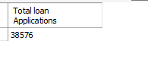

**Calculate last Two Month Data Aids in Month-on-Month Comparision**

**MTD Loan Applications (MTD = Month To Date)**

SELECT count(id) AS 'MTD_loan Applications'

FROM bank_data

WHERE month(issue_date) = 12;

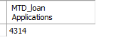

**PMTD Loan Applications (PMTD = Previous Month To Date)**

SELECT count(id) AS 'PMTD_Total_loan Applications'

FROM bank_data

WHERE month(issue_date) = 11;

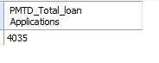

**Calculate Total Amount Of Loan Bank Distribuited ?**

**Total Funded Amount**

SELECT sum(loan_amount) AS 'Total Funded Amount'

FROM bank_data;

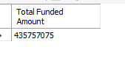

**MTD Total Funded Amount**

SELECT sum(loan_amount) AS 'MTD Total Funded Amount'

FROM bank_data

WHERE month(issue_date) = 12;



**PMTD Total Funded Amount**

SELECT sum(loan_amount) AS 'PMTD Total Funded Amount'

FROM bank_data

WHERE month(issue_date) = 11;

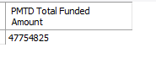

**Calculate Total Amount Of Loan Repayments Received By From Borrower’s**

**Total Amount Received**

SELECT sum(total_payment) AS 'Total Recieved Anount'

FROM bank_data;

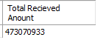

**MTD Total Amount Received**

SELECT sum(total_payment) AS 'MTD Total Recieved Amount'

FROM bank_data

WHERE month(issue_date) = 12;

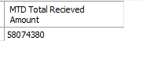

**PMTD Total Amount Received**

SELECT sum(total_payment) AS 'PMTD Total Recieved Amount'

FROM bank_data

WHERE month(issue_date) = 11;

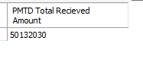

**Average Interest Rate Applied To The Loans**

SELECT avg(int_rate) * 100 AS 'Average Interest Rate';

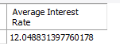

**MTD Average Interest**

SELECT AVG(int_rate) * 100 AS 'MTD Average Inerest Rate'

FROM bank_data

WHERE month(issue_date) = 12;

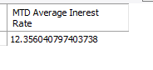

**PMTD Average Interest**

SELECT AVG(int_rate) * 100 AS 'PMTD Average Interest Rate'

FROM bank_data

WHERE month(issue_date) = 11;

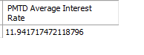

**Calculate Average Debt-to-Income Ratio of the Borrower’s**

SELECT avg(dti) AS 'Average DTI'

FROM bank_data;

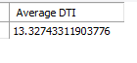

**MTD Average DTI**

SELECT AVG(dti) * 100 AS 'MTD Average DTI'

FROM bank_data

WHERE month(issue_date) = 12;

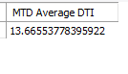

**PMTD Average DTI**

SELECT AVG(int_rate) * 100 AS 'PMTD Average DTI'

FROM bank_data

WHERE month(issue_date) = 11;



**GOOD LOAN ISSUED**

**The loans which are repaid on time.by customer’s with good repayment history = Good Loans**

**The loans which are not repaid on time.by customer’s with bad repayment history = Bad Loans**

**How many loans were repaid on time.by customer’s with good repayment history ?**

**Percentage of Good loans**

SELECT

(COUNT(CASE WHEN loan_status = "Fully Paid" or loan_status = "Current" THEN id END) * 100) / COUNT(ID) AS "Good Loan Percentage"

FROM bank_data

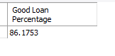

**Total Number Of Good Loan Applications.**

SELECT COUNT(ID) AS "Good Loan Applications"

FROM bank_data

WHERE loan_status = "Fully Paid" OR loan_status = "Current";

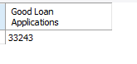

**Total Amount funded to Good Loans**

SELECT SUM(loan_amount) AS "Good Loan Funded Amount"

FROM bank_data

WHERE loan_status = "Fully Paid" OR loan_status = "Current";

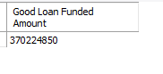

**Total Amount of loan repayment received from good loans.**

SELECT SUM(total_payment) AS "Good Loan Recieved Amount"

FROM bank_data

WHERE loan_status = "Fully Paid" OR loan_status = "Current";

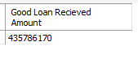

**BAD LOAN ISSUED**

**Bad Loan Percentage**

SELECT

(COUNT(CASE WHEN loan_status = "Charged Off" THEN id END) * 100) / COUNT(ID) AS "Bad Loan Percentage"

FROM bank_data;

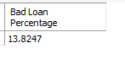

**Total Number Of Bad Loan Applications.**

SELECT COUNT(ID) AS "Bad Loan Applications"

FROM bank_data

WHERE loan_status = "Charged Off";

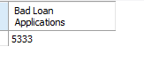

**Total Amount funded to Bad Loans**

SELECT SUM(loan_amount) AS "Bad Loan Funded Amount"

FROM bank_data

WHERE loan_status = "Charged Off";

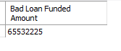

**Total Amount of loan repayment received from bad loans.**

SELECT SUM(total_payment) AS "Bad Loan Recieved Amount"

FROM bank_data

WHERE loan_status = "Charged Off";

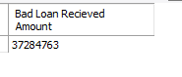

**LOAN STATUS**

SELECT

loan_status,

COUNT(id) AS 'Total Loan Applications',

SUM(loan_amount) AS 'Total Funded Amount',

SUM(total_payment) AS 'Total Recieved Amount',

AVG(int_rate)*100 AS 'Average Interest Rate',

AVG(dti)*100 AS 'Average DTI'

FROM bank_data

GROUP BY loan_status;

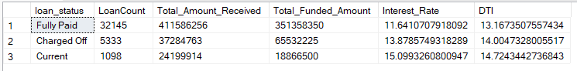

SELECT

loan_status,

SUM(loan_amount) AS 'MTD Total Funded Amount',

SUM(total_payment) AS 'MTD Total Amount Recieed'

from bank_data

GROUP BY loan_status;

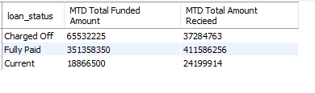

**BANK LOAN REPORT | OVERVIEW**

**MONTH**

SELECT

MONTH(issue_date) AS 'Month Number',

MONTHNAME(issue_date) AS 'Month Name',

COUNT(id) AS 'Total Loan Applications',

SUM(loan_amount) AS 'Total Funded Amount',

SUM(total_payment) AS 'Total Recieved Amount'

FROM bank_data

GROUP BY MONTH(issue_date), MONTHNAME(issue_date)

ORDER BY MONTH(issue_date);

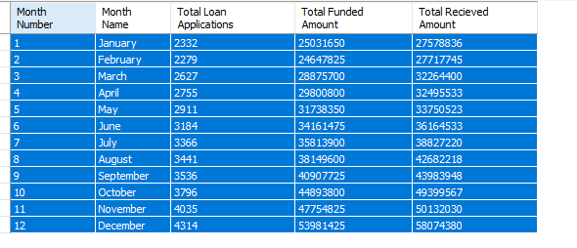

**STATE**

SELECT

address_state,

COUNT(id) AS 'Total Loan Applications',

SUM(loan_amount) AS 'Total Funded Amount',

SUM(total_payment) AS 'Total Recieved Amount'

FROM bank_data

GROUP BY address_state

order by address_state;

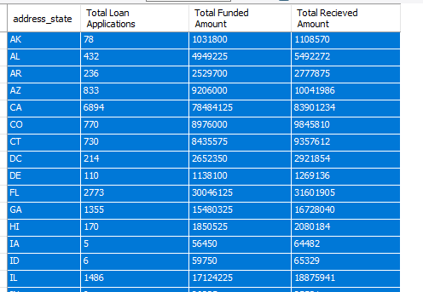

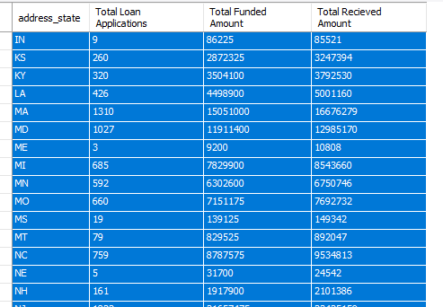

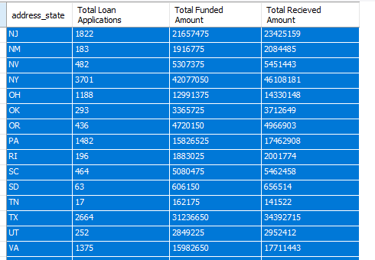

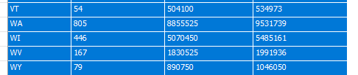

**TERM**

SELECT

term,

COUNT(id) AS 'Total Loan Applications',

SUM(loan_amount) AS 'Total Funded Amount',

SUM(total_payment) AS 'Total Recieved Amount'

FROM bank_data

GROUP BY term

order by term;

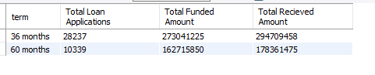

**EMPLOYEE LENGTH**

SELECT

emp_length,

COUNT(id) AS 'Total Loan Applications',

SUM(loan_amount) AS 'Total Funded Amount',

SUM(total_payment) AS 'Total Recieved Amount'

FROM bank_data

GROUP BY emp_length

order by COUNT(id) DESC;

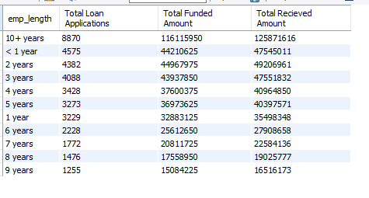

**PURPOSE**

SELECT

purpose,

COUNT(id) AS 'Total Loan Applications',

SUM(loan_amount) AS 'Total Funded Amount',

SUM(total_payment) AS 'Total Recieved Amount'

FROM bank_data

GROUP BY purpose

order by COUNT(id) DESC;

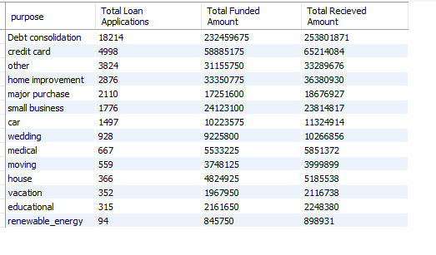

**HOME OWNERSHIP**

SELECT

home_ownership,

COUNT(id) AS 'Total Loan Applications',

SUM(loan_amount) AS 'Total Funded Amount',

SUM(total_payment) AS 'Total Recieved Amount'

FROM bank_data

GROUP BY home_ownership

order by COUNT(id) DESC;

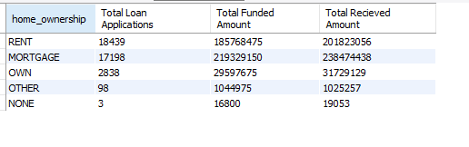

*Note: I have applied multiple Filters on all the dashboards. You can check the results for the filters as well by modifying the query and comparing the results.*

*For e.g*

*See the results when we hit the Grade A in the filters for dashboards.*

**Filters**

*SELECT*

*purpose,*

*COUNT(id) AS 'Total Loan Applications',*

*SUM(loan_amount) AS 'Total Funded Amount',*

*SUM(total_payment) AS 'Total Recieved Amount'*

*FROM bank_data*

*WHERE grade = 'A'*

*GROUP BY purpose*

*order by COUNT(id) DESC;*

